

**[EVENT TITLE]**

**NOTICE OF RACE & SAILING INSTRUCTIONS (NoR/SI)**

**To be supplemented by Local Sailing Instructions (LSI)**

**Published: [DATE OF FIRST VERSION]**

**Last amended: [DATE OF CURRENT VERSION]**

For a list of changes see NoR/SI 26

**1 DATE AND VENUE**

|  |  |  |
| --- | --- | --- |
| **Venue** | **Organizing Authority** | **Dates** |
| [VENUE]  [CITY]  [COUNTRY]  [GPS COORDINATES OF VENUE] | [NAME OF ORGANIZING AUTHORITY UNDER RRS 89.1] | [REGISTRATION DATE]  -  [PRIZE GIVING DATE] |

If the event is cancelled, any paid entry fees will be refunded in full.  
The organizing authority will not be liable for any other expenses incurred.

**2 RULES**

2.1 The event is governed by the rules as defined in The Racing Rules of Sailing (RRS). Other documents under RRS Definition: Rule (g) are published on the Official Notice Board and include:

2.1.1 [NP] [DP] [SP] The Equipment Regulations (ER); [DELETE IF NOT APPLICABLE]

2.1.2 [NP] [DP] [SP] The Support Team Regulations (including Support Vessels) (STR); and [DELETE IF NOT APPLICABLE]

2.1.3 [NP] [DP] The Athlete Media Regulations (AMR) [DELETE IF NOT APPLICABLE]

2.2 RRS Appendix F applies.

2.3 No national prescriptions apply.

2.4 For the Medal Series, Addendum FMS to these NoR/SI applies.

2.5 Local Sailing Instructions (LSI) will be published no later than on the day before the first warning signal and may change or supplement rules in these NoR/SIs.

2.6 In all rules governing the event;

2.6.1 The terms ‘rider’, ‘competitor’, ‘crew’, and ‘athlete’ mean a person competing, or intending to compete, in the event;

2.6.2 [SP] denotes a rule for which a standard penalty may be applied by the race committee or technical committee without a hearing as per NoR/SI 18.5. Additional rules marked [SP] are listed in NoR/SI 18This changes RRS A5. [SEE STANDARD PENALTY (AND DISCRETIONAL PENALTY) DOCUMENTS].

2.6.3 [NP] denotes a rule that shall not be grounds for protest by a kiteboard and for which the protest committee may refuse to hold a hearing. Additional rules marked [NP] are listed in NoR/SI 18. This changes RRS 60.1(a) and 63.1.

2.7 If there is a conflict between languages the English text will take precedence.

2.8 Changed Rules:

2.8.1 Add rule RRS 62.1(e): the action of a drone, or any other flying device.

2.8.2 Actions by event officials to implement COVID-19 guidance, protocols, or legislation, even if they later prove to have been unnecessary, will not be grounds for redress. This changes   
RRS 62.1(a).

2.8.3 From 1 hour before the scheduled warning signal of the first race until the end of the protest time of the last race of the event, a kiteboard may change her kite but only in the launching area.

**3 EVENTS, QUOTAS AND ELIGIBILITY**

Optional (and renumber accordingly for Olympic qualification events)

3.1 Only competitors registered by a Member National Authority (MNA) in good standing with World Sailing are eligible to enter the event.

3.1 There will be competition in the following events, classes and division:

|  |  |  |  |  |
| --- | --- | --- | --- | --- |
| **Event** | **Class** | **Division** | **Max. Quota** | **Min. Quota** |
| **Men’s Individual** | Formula Kite | [OPEN OR U21] | [QUOTA] | [QUOTA] |
| **Women’s Individual** | Formula Kite | [OPEN OR U21] | [QUOTA] | [QUOTA] |

U21: born 2003 or after  
U19: born 2005 or after

U17: born 2007 or after

3.1.1 Exceptions to the maximum quota may be made at the discretion of the organizing authority.   
[Additional places will be granted to one competitor per event for MNAs that have not entered any competitor.]

3.1.2 If less than five (5) competitors are registered in an event or division, they may be combined with the next higher age division and/or the other gender.

3.1.3 The Organizing Authority may cancel an event if the minimum number of entries has not been confirmed and paid 14 days before the on-site registration day of the event. Competitors will be notified of event cancellation by email and posting on the IKA website. Entry fees will be refunded.

3.2 World Sailing Eligibility in accordance with World Sailing Regulation 19 is required of all athletes.

3.3 Each athlete shall be registered as a World Sailing Sailor on the World Sailing website: <https://www.sailing.org/sailors/world-sailing-profile/>

3.4 On 1 March 2022 World Sailing published the following recommendations in reaction to the situation in Ukraine: <https://www.sailing.org/2022/03/01/world-sailing-statement-6/>. To help preserve the integrity and safety of the event, entries shall not be open to competitors and support persons holding only Russian or Belarussian nationality. The Organizing Authority may amend this rule following any further World Sailing decisions on the situation with Russia and Belarus.

3.5 Each athlete shall be a national of the country they represent (see World Sailing Regulations 19.8 to 19.18). Each athlete shall upload proof of their nationality to the online registration system.

3.6 Each competitor shall be a member of an IKA member (National Class Association) of either his/her nationality or his/her country of permanent residence. Evidence of membership shall be presented at registration if requested. If no current member exists, the competitor shall become individual member of IKA. Membership formalities may be completed on site.

**4 ENTRY, REGISTRATION AND FEES**

Optional (and renumber accordingly for Olympic qualification events)

4.1 The Qualification System for the event shall apply and confirms the quota process and entry deadlines. The Qualification System is published on the official notice board.

4.2 Applications for quota places in accordance with the Qualification System shall be made through the online registration system at [LINK TO REGISTRATION PAGE].

4.3 MNAs with entrants shall register their main point of contact and team leader through the online registration system.

4.1 Competitor registrations shall be made through [LINK TO REGISTRATION PAGE]

4.2 Entries will be accepted on a first come-first served basis. [OR DESCRIBE OTHER MEANS OF ENTRY ALLOCATION]

4.3 Registration fees per competitor are as follows (all plus credit card fees) and are not refundable except if the event is cancelled:

|  |  |  |  |  |
| --- | --- | --- | --- | --- |
| Early Bird  Entry Fee | Early Bird Deadline | Regular Entry Fee | Regular Entry Deadline | Late  Entry Fee |
| [FEE] | [DATE] | [FEE] | [DATE] | [FEE] |

4.4 Competitors shall provide the following documentation prior to completing registration formalities on site:

* Proof of entry fee payment;
* Evidence of national class association membership;
* Proof of nationality;
* Proof of age;
* World Sailor ID;
* Parental/legal guardian consent - for those under the age of 18; (see attachments) and
* Medical Treatment Permission - for those under the age of 18 or on their parent’s medical insurance policy (see attachments).
* [OR DESCRIBE OTHER REQUIREMENTS AS NEEDED]

4.5 Support Teams

4.5.1 Support persons, support team vessels and team leaders shall be registered online and comply with the local legislation and the Support Team Regulations. The local organizing authority may refuse registrations or accept later registrations at their discretion.

4.5.2 The Organizing Authority may, at its discretion refuse support team vessels entry to the venue if they are deemed unsuitable. Generally, open vessels less than 7.5 metres in length, having minimum or no superstructure (cabin, coach house, bridge etc.), will be considered suitable.

4.5.3 The registration fee for support persons and support vessels are as follows:

|  |  |
| --- | --- |
| **Support Person Type** | **Entry Fee** |
| **On-Water Support Persons (incl. benefits as for competitors)** | 0 EUR |
| **Other Support Persons (incl. benefits as for competitors)** | 50 EUR |

The amount shall be paid in cash during on-site registration or via credit card during the registration process.

This support vessel fee includes slipway/crane use, trailer, and car parking in the marina.

4.5.4 Support persons shall provide the following documentation prior to completing registration formalities on site:

* Proof of registration fee payment;
* List of athletes or MNAs supported;
* Boat Driving License (if applicable); and

[OR DESCRIBE OTHER REQUIREMENTS AS NEEDED]

4.6 [NP] [SP] [DP] Competitors, support persons and team leaders shall personally sign the registration form at the Race Office at the specified time.

4.7 An entry is not complete until payment has been received and the kiteboard or support persons has completed registration. Registration may include equipment and entry requirement checks.

**5 SCHEDULE**

5.1 The schedule will be as follows (all times are local):

|  |  |  |
| --- | --- | --- |
| **Date** | **Activity** | **Time** |
| **[DATE]** | Arrival, venue opens |  |
| **[DATE]** | On-Site Registration | [FROM-TO] |
| **[DATE]** | Equipment Inspection | [FROM-TO] |
|  | Practice Race | [TIME] |
|  | Equipment Inspection | [FROM-TO] |
|  | Profile Picture Photo Shoot (mandatory) | [FROM-TO] |
|  | Opening Ceremony / Welcome (tbc) | [TIME] |
|  | Technical Meeting (online) | [TIME] |
| **[DATE FROM]– [DATE TO]** | Racing (see Addendum 3) | [TIME] |
| **[DATE]** | Prize Giving and Closing Ceremony | [TIME] |
| **[DATE]** | Departure, venue closes |  |

5.2 There will be a daily briefing for competitors and support persons / team leaders [WHERE AND WHEN]

5.3 Addendum 3 shows the provisional race schedule, including the time of the first warning signal and the number of scheduled races.

5.4 Any change to Addendum 3 will be posted no later than 21:00 on the previous evening of any race affected.

5.5 The Race Committee may change the schedule to sail one race ahead of schedule. The Race Committee may schedule racing on a reserve day.

5.6 Not more than a total of 6 races per fleet will be sailed per day.

5.7 The Medal Series will not be scheduled on the same day as an Opening Series race for that event.

5.8 The first warning signal for the first race on date will not be before [TIME OF FIRST WARNING SIGNAL].

5.9 On the last day of racing no warning signal will be made after time. [TIME OF LAST WARNING SIGNAL]

1. **FORMAT AND SCORING**

6.1 One race for all fleets is required to be completed to constitute an event.

6.2 The format for each event will be:

|  |  |  |
| --- | --- | --- |
| **Event** | **Format** | **Number of Races** |
| **Formula Kite  (19 and more kiteboards)** | Opening Series + Medal Series (Semi Finals and Finals) for the top ten kiteboards, 1 non-discardable Last Race for all other kiteboards.  **See Addendum 5** | 20 + Medal Series / Last Race  (4 races per day) |
| **Formula Kite (less than 19 kiteboards)** | Opening Series + Short Track Series  **See Addendum 6** | 16 + 2  (4 races per day) |
| **Formula Kite**  (for short and Grand Prix level events) | Single Series which may be divided into a qualifying series and a final series.  **See Addendum 7** | 12-16  (4 or more races per day) |

6.3 Events may be split into groups when there are more than 30 entries in an event. Events will be split into groups when there are more than 40 entries in an event.

6.4 A Medal Series for the top ten ranked kiteboards / Last Race or a Short Track Series will be sailed if seven or more Opening Series races have been completed. The opening series may be extended if less than seven races have been completed.

6.5 Division rankings (if any) will be established by simple extraction from the overall standings.

6.6 To request correction of an alleged error in posted race or series results, a kiteboard may submit a scoring enquiry through the online platform.

**7 NOT IN USE**

**8 COURSES AND RACING AREAS**

8.1 The diagrams in Addendum 1 show the courses, the course designations, the approximate angles between legs, the order in which marks are to be passed, and the side on which each mark is to be left.

8.2 No later than the warning signal, the race committee starting vessel will display the course to be sailed.

8.3 If mark P is not set, it shall be disregarded.

8.4 Courses will not be shortened. This changes RRS 32.

8.5 Courses will not be changed. This changes RRS 33.

8.6 Addendum 4 shows the location of the venue and the course area.

**9 STARTING AND FINISHING**

9.1 To alert kiteboards that a race or sequence of races will begin soon, the starting line flag will be displayed with one sound at least five minutes before a warning signal is made.

9.2 The warning signal for each succeeding race will be made as soon as practicable.

9.3 The starting line will be between a staff displaying an orange flag on the race committee vessel and either:

a) the course side of the port-end inflatable mark, or

b) a staff displaying an orange flag on the race committee vessel on the port end.

9.4 A kiteboard starting later than 1 minute after her starting signal will be scored Did Not Start. This changes RRS A5.1 and A5.2

9.5 [NP] [DP] When a starting sequence is in progress, kiteboards whose warning signal has not been made shall avoid the starting area. The starting area is defined as an area 300 meters from the starting line and marks in all directions.

9.6 The finishing line will be between a staff displaying a blue flag and the course side of the nearby finishing mark.

9.7 [NP] [DP] Kiteboards that have finished shall sail clear of the finish area.

**10 TIME LIMITS AND TARGET TIMES**

10.1 Time limits and target times, in minutes, are as follows:

|  |  |  |  |  |
| --- | --- | --- | --- | --- |
|  | **Target Time** | **Race Time Limit** | **Mark 1 Time Limit** | **Finishing**  **Window** |
| **Opening Series**  **Last Race** | 12 | 24 | 6 | 6 |
| **Medal Series**  **Short Track Series** | 7 | 14 | 4 | 3 |

10.2 If no kiteboard has passed Mark 1 within the Mark 1 time limit, the race will be abandoned.

10.3 Not meeting the target time will not be grounds for redress. This changes RRS 62.1(a).

10.4 Kiteboards not finishing within the Finish Time Window (time after the first kiteboard starts, sails the course and finishes) will be scored Did not Finish without a hearing. This changes RRS 35, A5.1 and A5.2

**11 [NP] [DP] [SP] IDENTIFICATION**

**AND ADVERTISING**

11.1 When provided by the organizing authority, kiteboards or competitors shall carry, display or wear the following as instructed:

11.1.1 Competition bibs for all competitors with an individually assigned competition number, worn as intended over all other clothing and equipment at any time when afloat;

11.1.2 Event leader bibs, worn as intended over all other clothing and equipment at any time when afloat;

11.1.3 Event advertising and Look of the event;

11.1.4 Cameras, camera dummies, sound and other media equipment;

11.1.5 Tracking, timing and electronic umpire system equipment.

11.2 Kiteboards shall not display advertising from previous events.

**12 COMMUNICATION**

12.1 The official notice board and event management system for requests is online here:

[LINK TO OFFICIAL NOTICE BOARD ONLINE]

12.1.1 Documents governing the event, except the LSI, will be published on the official notice board no later than two weeks before the on-site registration day of the event.

12.1.2 Complementary information may be posted on a notice board in the venue.

12.1.3 Informal communication may be sent through a [MESSENGER] group at [LINK]

12.2 The location of the official flagpole will be described in the LSI.

12.3 When flag AP is displayed ashore, ‘1 minute’ is replaced with ‘not less than 20 minutes’ in the race signal AP. This changes RRS Race Signals.

12.4 Flag K displayed afloat and ashore with two sounds means ‘Races not started are postponed. The warning signal will be made not less than 5 minutes after removal (with one long sound) unless at that time the race is postponed again or abandoned.’

12.5 [NP] [DP] Flag G displayed ashore with two sounds means ‘No kiteboard shall go afloat until this signal is removed (with one long sound). The warning signal will be made not less than 20 minutes after removal.’

12.6 [NP] [DP] Flag G displayed afloat means ‘Kiteboards not racing shall return ashore as soon as reasonably possible.'

12.7 A signal displayed at the finish vessel applies only to the fleet that is finishing. This changes RRS Race Signals preamble.

12.8 The LSIs will be posted on the official notice board no later than on the day before the first warning signal.

12.9 While racing, except in an emergency or when using equipment provided by the race committee or Organising Authority, a kiteboard shall not make voice, radio or data transmissions and shall not receive voice, radio or data communication that is not available to all kiteboards. This restriction also applies to mobile telephones.

**13 CHANGES TO NOTICE OF RACE AND SAILING INSTRUCTIONS**

Any change to the NoR/SI and the LSI will be posted 30 minutes before it will take effect.

**14 [NP] [DP] [SP] SAFETY**

**REGULATIONS**

14.1 When Flag G is displayed ashore, competitors returning ashore shall either personally check in at the official flag pole where the flag is displayed, or be reported as safe by their support persons.

14.2 Kiteboards not leaving the launching area for a scheduled race shall promptly notify the race committee.

**15 [NP] [DP] CODE OF CONDUCT**

15.1 Competitors and support persons shall:

15.1.1 comply with any reasonable request from an event official. Non-compliance may be misconduct.

15.1.2 not in any way interfere with the functionality of supplied media or timing equipment.

15.2 Kiteboards not racing shall remain clear of areas where kiteboards are racing and any official boat.

**16 [NP] [DP] [SP] EQUIPMENT   
INSPECTION AND REPLACEMENT**

16.1 This event is an international event for the purpose of RRS G1.1.

16.2 Competitors shall submit a complete and correct Equipment Registration Form before 1900 on the day before the first scheduled equipment inspection through [ELECTRONIC FORM WITH LINK, OR PAPER FORMS]. Exceptions may be authorized by the Event Technical Committee.

16.2 Kiteboards shall be available for inspection from the time specified in the schedule.

16.3 Information on equipment to be inspected on each scheduled equipment inspection day will be published before 20:00 hours on the day before the first scheduled equipment inspection day, and after racing each day within the protest time limit. Competitors shall present the equipment to be inspected at the time published.

16.4 The fact that race officials may conduct inspections of a kiteboard does not reduce the responsibilities of each competitor set out in the rules.

16.5 After being inspected on the scheduled equipment inspection day, or after 1900 on the scheduled equipment inspection day (whichever is earlier), no kiteboard or equipment subject to registration shall be removed from the venue or the adjacent waters without written permission of the Event Technical Committee. [define berthing or not]

16.6 Kiteboards are required to comply with RRS 78.1 and Event Equipment Rules from one hour before the first scheduled warning signal until the end of the protest time of the last race of the event.

16.7 Upon arriving ashore, a kiteboard may be instructed by a member of the Event Technical Committee to proceed immediately to a designated area for inspection.

16.8 Substitution of damaged or lost equipment will not be allowed unless authorized by the Event Technical Committee. Requests for substitution shall be made at the first reasonable opportunity through the online platform. [OR DESCRIBE AVAILABILITY OF PAPER FORMS]

16.9 ER 3.5.(a)/(b) applies: (Note: the default as per class rules is that kites may be replaced with another kite from the same range, not necessarily an identical kite)

(a) Kites shall only be replaced with kites of the same brand, make, and size, or  
 [recommended for senior World and European Championships, Olympic Qualification  
 events, Olympic and major Regional Games]

(b) Kites shall only be replaced with a kite of the same size range.  
 [class rules default for all other competitions]

**17 INTERNATIONAL JURY AND  
 TECHNICAL COMMITTEE**

17.1 An international jury will be appointed in accordance with RRS 91(b). Its decisions will be final as provided in RRS 70.5.

17.2 An Event Technical Committee will be appointed in accordance with RRS 92.1.

**18 HEARING REQUESTS AND PENALTIES**

18.1 Hearing request forms are available through the online platform. [OR DESCRIBE AVAILABILITY OF PAPER FORMS]. Protests and requests for redress or reopening shall be submitted before the appropriate time limit.

18.2 The protest time limits will be described in the LSI.

18.3 Notices will be posted within 15 minutes of the protest time limit to inform competitors of hearings in which they are parties or named as witnesses. Hearings will be held beginning at the time and location posted. Hearings may be scheduled to begin up to 15 minutes before the end of the protest time limit.

18.4 Penalties for breaches of the ER, STR, AMR, RRS 50, RRS 78.1, class rules or rules in the NoR and SIs marked [DP], should the case go to a hearing, are at the discretion of the protest committee.

18.5 For breaches of NoR/SI marked [SP], breaches of ER 2.3 and 2.4, and breaches of Class Rules B.5, C.3.2, C.4, C.6.2, C.7.3, C.7.4, C.8.4, C.10.2, and C.10.4, the race committee or technical committee may apply a standard penalty without a hearing to the race(s) closest in time to the incident. The scores of other kiteboards shall not be changed; therefore, two kiteboards may receive the same score. However, the race committee or technical committee may protest a kiteboard when they consider the standard penalty to be inappropriate. A kiteboard that has been penalized with a standard penalty can neither be protested for the same incident by another kiteboard nor can another kiteboard request redress for this race committee or technical committee action. This changes RRS 60.1, 63.1 and RRS A5.

18.6 A kiteboard may not protest a kiteboard for non-compliance with building specifications. The protest committee may refuse to hold a hearing when a kiteboard protests based on this rule. This changes RRS 60.1(a) and 63.1.

18.7 RRS 62.2(a) and 66.2(a) also apply on the last day of Q2 and Q3, the last day of the Opening Series, and on the day of the Short Track Series.

**19 [DP] SUPPORT TEAMS INCLUDING  
SUPPORT TEAM VESSELS**

19.1 By registering as a support person, each such person agrees to be governed by the rules.

19.2 A support team vessel includes any vessel that is under the control or direction of a support person as defined in the RRS and also includes any person gathering data that may be used by a team or competitor.

19.2 Support team vessels shall display the 3-letter code of their World Sailing MNA at all times while afloat clearly visible from both sides of the vessel. The minimum height for the letters shall be 200 mm.

19.3 Limitations of equipment that may be carried and mandatory equipment that shall be carried on support team vessels will be detailed in the STR.

19.4 Except when participating in rescue operations as requested or instructed by the race committee, support boats shall remain in the area defined in Addendum 2 from the time of the preparatory signal for the first group to start until all kiteboards have finished or retired or the race committee signals a postponement, general recall or abandonment.

19.5 A MNA, competitor, or support person shall not leave any device, piece of equipment, buoy, marker or similar item permanently in the water.

**20 [NP] [DP] PRIZES,   
VICTORY CEREMONY**

20.1 [DESCRIBE PRIZES FOR TOP X COMPETITORS]

20.2 [DESCRIBE MEDALS / DIPLOMA FOR TOP X COMPETITORS]

20.3 Rankings / Performance Certificates will be provided for age divisions with a minimum of 5 entries after the end of the competition:

U21: born 2003 or after  
U19: born 2005 or after

U17: born 2007 or after

20.4 If a competitor who finished in the top 3 leaves the event before the conclusion of the victory ceremony or, if other competitor, leaves the venue before the day before the victory ceremony, the OA may exclude that competitor from the next Championship or impose any similar sanction.

20.5 The OA may reduce or remove a prize in the case of misconduct or refusal to comply with any reasonable request, including attendance at official functions.

**21 [NP] [DP] INSURANCE**

21.1 Each ‘person in charge’ (see RRS 46) shall hold a valid insurance certificate showing proof of third-party liability coverage of at least [MINIMUM AMOUNT, I.E 500.000 EUR] or equivalent per incident.

21.2 Each support vessel shall have valid insurance including third party liability coverage of at least [MINIMUM AMOUNT, I.E 1.500.000 EUR] (or equivalent) per incident.

21.3 The Organizing Authority is not responsible for verifying the status or validity of certificates.

**22 DOPING CONTROL**

Competitors are reminded of the World Sailing rules and regulations concerning the use of banned methods and substances, which are contained in the World Sailing Anti-Doping Code. Drug testing may take place during this event.

**23 RISK STATEMENT**

23.1. In cases of force majeure or on grounds of administrative orders or for safety reasons, the organizing authority is entitled to make changes in the realization of the event or to cancel the event. This does not constitute any liability by the organizer towards the participant, if the reasons for the changes or the cancellation do not result from a wilful or grossly negligent behaviour of the organizer.

23.2 In case of a violation of obligations that do not constitute primary or material contractual duties (cardinal obligations), the liability of the organizer for financial and property damages incurred by the participant during or in connection with the participation in the event and resulting from a conduct of the organizer, the involved classes and their representatives, servants or agents (including but not limited to race committee , protest committee and technical committee), is restricted to damages that were caused wilfully or grossly negligent. When a violation of cardinal obligations occurs due to minor negligence, the liability of the organizer is limited to foreseeable, typical damages.

23.3 Competitors and support persons participate in the event entirely at their own risk and they are reminded of the provisions of RRS 3, Decision to Race. Kiteboarding is by its nature an unpredictable sport and therefore involves an element of risk. By taking part in the event, each competitor agrees and acknowledges that:

* They acknowledge that there are risks involved in the Event. They fully realise the dangers of participating in the Event, and fully assume the risks associated with their participation and their wellbeing and safety during and after the Event.
* They understand and acknowledge that the Event organisers (including all officials and event volunteers) provide no warranties, regarding their wellbeing and safety.
* They acknowledge that participating in this event may involve a test of a person's physical and mental limits and carries with it the potential for death, serious injury, and property loss. The risks include, but are not limited to, those caused by the elements, facilities, temperature, weather, condition of participants, equipment, vehicular traffic, lack of hydration, and actions of other people including, but not limited to, participants, volunteers, officials, and/or producers of the event.
* They agree that to the extent permissible by law, World Sailing, the International Kiteboarding Association, their classes, the event organisers (including all officials and event volunteers), IKA, the sponsors and other parties associated with the Event, have no liability to them whatsoever for any direct or indirect loss, (including, but not limited to injury or death) sustained by them during or in any way related to their participation in the Event.
* They WAIVE, RELEASE, AND DISCHARGE from any and all liability, including but not limited to, liability arising from the negligence or fault of the entities or persons released, for their death, disability, personal injury, property damage, property theft, or actions of any kind which may hereafter occur to them including their traveling to and from this event, THE FOLLOWING ENTITIES OR PERSONS: World Sailing, The International Kiteboarding Association, their classes, the event organisers (including all officials and event volunteers), IKA, the sponsors and other parties associated with the Event, employees, volunteers, representatives, and agents, and the event holders, sponsors, and volunteers;
* They INDEMNIFY, HOLD HARMLESS, AND PROMISE NOT TO SUE the entities or persons mentioned in the above paragraphs from any and all liabilities or claims made as a result of participation in this event, whether caused by the negligence of release or otherwise.
* They have taken medical advice on any pre-existing medical conditions and confirm that it is medically safe for them to participate in the Event.
* They are responsible for the safety of themselves, their equipment and their other property at any time.
* They are satisfied that their equipment is in good order, equipped to compete in the event and they are fit to participate;
* They accept responsibility for any injury, damage or loss to the extent caused by their own actions or omissions;
* They consent to receive medical treatment which may be deemed advisable in the event of injury, accident, and/or illness during this event.
* They acknowledge that the provision of a race management and rescue team, judges, umpires and other officials and volunteers by the organizer does not relieve them of their own responsibilities;
* They acknowledge that the provision of rescue craft cover is limited to such assistance, particularly in extreme weather conditions, as can be practically provided in the circumstances.
* Participants are made aware that small unmanned aircrafts (drones) may fly over them and operate in close vicinity to them.

**24 [NP] [DP] [SP] MEDIA RIGHTS**

24.1 By participating in the event, competitors and support persons automatically grant to the organizing authority, IKA, all involved classes, their sponsors and World Sailing, the right in perpetuity to make, use and show, from time to time at their discretion, any motion pictures and live, taped or filmed television and other reproductions of the athlete during and after the period of the event without compensation.

24.2 Competitors shall comply with the Competitor Media Guide (AMR). The AMR will include further information on television production, press conferences, interviews, mixed zones, and promotion of the event. [SEE ATHLETE MEDIA REGULATION, MAKE OTHER PROVISIONS OR DELETE]

**25 DATA PROTECTION AND PRIVACY**

With registration the competitor or support person agrees on data usage as defined in this data protection and privacy notice. See Privacy Notice in Addendum 8.

Reference is made to data protection of personal information and data. Any personal information and data given to the organizers will be used only as follows:

(a) All data regarding participating athletes, support persons and their kiteboard will be processed and archived for the purpose of this event and events of similar nature that might be of interest to the participant.

(b) Personal information contains the participant’s real name, date of birth, home club, boat type. boat number, address data, mobile phone, email address and emergency contact information. In particular, results, calculatory and visual analyses, position monitoring and race analyses will be published with reference to the competitors’ names.

**26 DOCUMENT CHANGE HISTORY**

[DATE OF INITIAL VERSION] Initial Version

[DATE OF AMENDMENT] [AMENDMENTS]

**FURTHER INFORMATION  
 (NOT PART OF THE NOTICE OF RACE)**

**Contacts**

|  |  |  |
| --- | --- | --- |
| **Organization** | **Name / Surname** | **Email** |
| **LOA** |  |  |
|  |  |  |

**Site Information**

[INSERT INFORMATION]

**Competitors' lounge**

[INSERT INFORMATION]

**Medical services and facilities**

[INSERT INFORMATION]

**Accommodation and travel**

[INSERT INFORMATION]

**Transport**

[INSERT INFORMATION]

**Catering**

[INSERT INFORMATION]

**ADDENDUM FMS**

**KITEBOARDING MEDAL SERIES**

*(Version 28 March 2023) – This addendum applies to all medal series races and all pre-race or post-race activities related to them. The rules of this addendum override any conflicting rules in the notice of race and the sailing instructions. This changes rule 63.7.*

**FMS 1 Changes to Rules Involving Protests, Requests for Redress, Penalties and Exoneration**

FMS 1.1 Rule F5 is deleted.

FMS 1.2 Rule 60.1 is replaced with ‘A kiteboard may protest another kiteboard or request redress provided she complies with rules FMS 3.1 and FMS 3.6

FMS 1.3 Rules 62.1(a), (b) and (d) are deleted.

**FMS 2 SCORING INFORMATION**

FMS 2.1 At the finishing line, the race committee will display each kiteboard’s finishing place or score in the race, together with flag B and one sound. The scoring information and flag B will be displayed for one minute and removed with one sound.

FMS 2.2 When the race score of a kiteboard may be different than her finishing position, the race committee shall display a yellow flag on the finishing area before flag B is removed.

FMS 2.3 If the race committee changes the scoring information while it is displayed, it will display flag L with one sound. The scoring information and flag B will continue to be displayed for one minute after any changes are made.

**FMS 3 PROTESTS, REQUESTS FOR REDRESS AND PENALTIES**

FMS 3.1 While racing, a kiteboard may protest another kiteboard under a rule of Part 2, except rule 14, but only for an incident in which she was involved, or under rule 31. To do so she shall hail ‘Protest’ and conspicuously raise one arm at the first reasonable opportunity for each. This changes rules 60.1 and 61.1.

FMS 3.2 A kiteboard involved in the incident may acknowledge breaking a rule by promptly taking a One-Turn Penalty in accordance with rule 44.2.

FMS 3.3 UMPIRED RACES

FMS 3.3.1 A kiteboard that protests as provided in rule FMS 3.1 is not entitled to a hearing. An umpire may penalize any kiteboard that broke a rule and was not exonerated, unless the kiteboard took a voluntary penalty. This changes rule 63.1.

FMS 3.3.2 When a kiteboard

(a) breaks rule 31 and does not take a penalty, or

(b) gains an advantage despite taking a penalty, or

(c) deliberately breaks a rule, or

(d) commits a breach of sportsmanship,

an umpire may penalize her without a protest by another kiteboard.

FMS 3.3.3 (a) When the umpires decide that a kiteboard has broken a rule, they will apply a penalty   
 of 1.1 points to the kiteboard. This shall not change the score of the other kiteboards.

(b) If the kiteboard caused injury, serious damage or a tangle or, despite taking a penalty,   
 gained a significant advantage or caused significant disadvantage to the other   
 kiteboard in the race or series by her breach, the kiteboard will be disqualified

(c) The umpires may report the incident to the protest committee for further action.

FMS 3.3.4 The umpire decisions will be reflected in the race scores displayed by the race committee as per FMS 2.1

FMS 3.4 NOT UMPIRED RACES

FMS 3.4.1 This rule applies when the race has not been umpired. Rule FMS 3.3 does not apply. To signal that a race has not been umpired, the race committee will display flag P on the finishing vessel.

FMS 3.4.2 Protests and requests for redress need not be in writing. The protest committee may schedule the hearing, inform the parties of the time and place of the hearing, take evidence, conduct the hearing, and communicate its decision in any way it considers appropriate, which may be orally. This changes rules 61.2, 62.2, 63 and 65.

FMS 3.5 A kiteboard intending to

1. protest another kiteboard when FMS 3.4 applies,
2. protest another kiteboard under a rule other than rule 28, or a rule listed in FMS 3.1,

(c) protest another kiteboard under rule 14 if there was contact that caused damage,   
 injury or a tangle, or

(d) request redress,

shall hail the race committee during the display of flag B except that if a kiteboard does not finish a race, she may notify her hearing request to any official boat before the removal of flag B.

This changes rules 61.1 and 61.3

FMS 3.6 (a) When the race committee receives a notification of protest, it will promptly inform   
 the protest committee. The hearing will start at the protest committee station within   
 five minutes unless the protest committee decides otherwise.

(b) If no protest or request for redress is received when flag B is removed, the race   
 committee will display a green and white flag with one sound.

FMS 3.7 If the protest committee decides that a breach of a rule has had no effect on scoring a race-win, it may postpone the hearing or make any arrangement it decides is equitable.

FMS 3.8 For protests under rule FMS 3.4,

(a) When the protest committee decides that kiteboard has broken a rule, they will apply   
 a penalty of 1.1 points to the kiteboard

(b) If the kiteboard caused injury, serious damage or a tangle or, despite taking a penalty,   
 gained a significant advantage or caused significant disadvantage to the other   
 kiteboard in the race or series by her breach, the kiteboard will be disqualified

FMS 3.9 After making its decision, the protest committee will display any penalties imposed or redress given together with flag L and one sound.

**FMS 4 REQUESTS FOR REOPENING; APPEALS; OTHER PROCEEDINGS**

FMS 4.1 No proceedings of any kind may be taken in relation to any action or non-action by an umpire.

FMS 4.2 A kiteboard may not base an appeal on an alleged improper action, omission or decision of the umpires or the protest committee. This changes rule 70.1.

Rule 66.2 is replaced with ‘A hearing shall not be reopened based on a request of a *party* to that hearing.’

FMS 4.3 The race committee will not protest a boat.

FMS 4.4 The protest committee may protest a boat under rule 60.3. However, it will not protest a boat for breaking a rule listed in rule FMS 3.1, or rule 14 unless there is damage, injury or tangle.

FMS 4.5 The technical committee will not protest a kiteboard, except under rule 60.4 when it decides that a boat or personal equipment does not comply with the class rules, rule 50, or the rules in the equipment regulations of the event, if such exist. In such a case, the technical committee shall protest. The time limit for protests under this rule is the same as in rule FMS 3.5. The protest committee shall extend the time limit if there is a good reason to do so.

**ADDENDUM 1**

**COURSE DIAGRAMS**

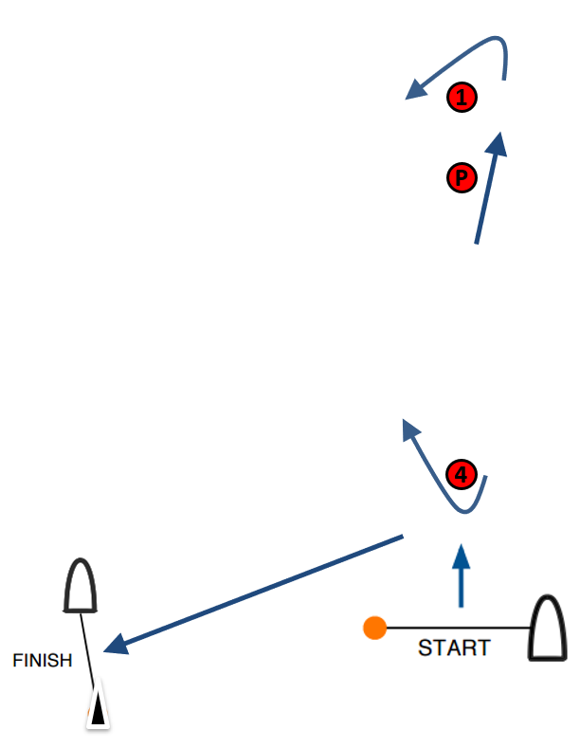

**X 1: Start – Pp – 1p – Pp – 4s – Finish**

**X 2: Start – Pp – 1p – Pp – 4s – Pp – 1p – Pp – 4s – Finish**

**X 3: Start – Pp – 1p – Pp – 4s – Pp – 1p – Pp – 4s – Pp – 1p– Pp – 4s – Finish**

All distances and course angles are approximate.

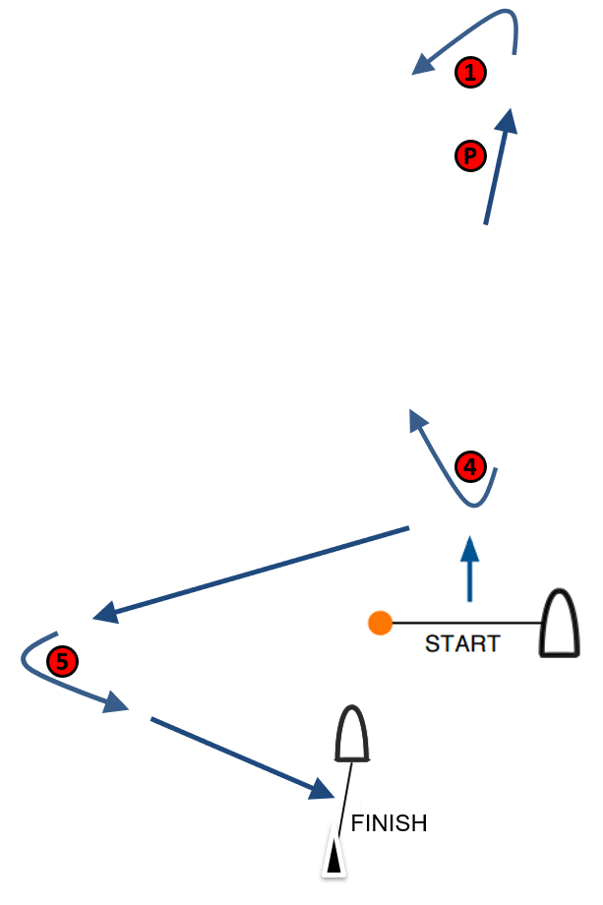

**XS 1: Start – Pp – 1p – Pp – 4s – 5p – Finish**

**XS 2: Start – Pp – 1p – Pp – 4s – Pp – 1p – Pp – 4s – 5p – Finish**

**XS 3: Start – Pp – 1p – Pp – 4s – Pp – 1p – Pp – 4s – Pp – 1p– Pp – 4s – 5p – Finish**

All distances and course angles are approximate.

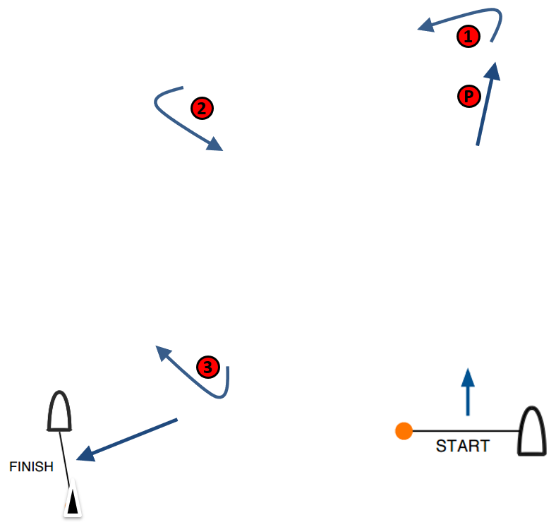

**B 1: Start – Pp – 1p – 2p – 3s – Finish**

**B 2: Start – Pp – 1p – 2p – 3s – 2p – 3s – Finish**

**B 3: Start – Pp – 1p – 2p – 3s – 2p – 3s – 2p – 3s – Finish**

All distances and course angles are approximate.

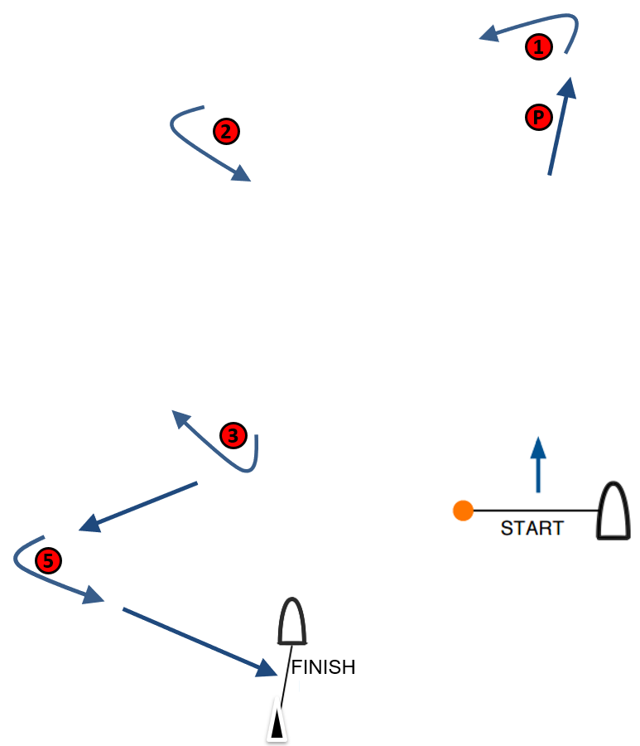

**BS 1: Start – Pp – 1p – 2p – 3s – 5p – Finish**

**BS 2: Start – Pp – 1p – 2p – 3s – 2p – 3s – 5p – Finish**

**BS 3: Start – Pp – 1p – 2p – 3s – 2p – 3s – 2p – 3s – 5p – Finish**

All distances and course angles are approximate.

**ADDENDUM 2**

**COURSE AREA LIMITATIONS**

|  |  |
| --- | --- |
| **X** |  |
| **B** |  |
| **XS** |  |
| **BS** |  |

**ADDENDUM 3**

**SCHEDULE OF RACES**

|  |  |  |  |  |  |
| --- | --- | --- | --- | --- | --- |
| **Event Stage** | **[DAY 1]** | **[DAY 2]** | **[DAY 3]** | **[DAY 4]** | **[DAY 5]** |
|  | Warning Signal | Warning Signal | Warning Signal | Warning Signal | Warning Signal |
|  | # of races | # of races | # of races | # of races | # of races |
| **Q1** | **[TIME]** |  |  |  |  |
|  | 4 |  |  |  |  |
| **Q2** |  | **[TIME]** |  |  |  |
|  |  | 4 |  |  |  |
| **Q3** |  |  | **[TIME]** | **[TIME]** |  |
|  |  |  | 4 | 4 |  |
| **Last Race** |  |  |  |  | **[TIME]** |
|  |  |  |  |  | 1 |
| **Medal Series** |  |  |  |  | **[TIME]** |
|  |  |  |  |  | As required |
| **Opening Series** | **[TIME]** | **[TIME]** | **[TIME]** | **[TIME]** |  |
|  | 4 | 4 | 4 | 4 |  |
| **Short Track Series** |  |  |  |  | **[TIME]** |
|  |  |  |  |  | 2 |

[AMEND ACCORDING TO FORMAT, EVENT LENGTH ETC]

The times of the first warning signals will be updated before 2100 on the day before the first warning signal.

The schedule of races may be amended at any time pending weather conditions.

**ADDENDUM 4**

**COURSE AREA AND VENUE MAP**

[INSERT INFORMATION AND MAPS]

**ADDENDUM 5**

**OPENING SERIES / MEDAL SERIES**

**1 Opening Series**

1.1 The Opening Series may be divided into phases Q1, Q2 and Q3.

**1.2 Opening Series – Phases Q1 and Q2**

1. Phase Q1: On the first day of racing, kiteboards will be assigned to fleets yellow, blue, red etc., of, as nearly as possible, equal size and ability. Assignments will be made by the race committee and will be posted at least 30 minutes before the first warning signal is made. Those assignments will not be grounds for redress. This changes RRS 62.1(a).
2. Phase Q2: Kiteboards will be reassigned to fleets after each day of racing, except if only one race is completed by all fleets. If all fleets have completed the same number of races, kiteboards will be reassigned on the basis of their ranks in the series. If all fleets have not completed the same number of races, the series scores for reassignment will be calculated for those races, numbered in order of completion, completed by all fleets. For three fleets, and similarly for any other number, reassignments will be made as follows:

First Yellow  
Second Blue  
Third Red  
Forth Red  
Fifth Blue  
Sixth Yellow  
Seventh Yellow  
etc.

1. Reassignments of fleets will be based on the ranking available at 2100 on the day before they take effect, regardless of pending hearings.
2. If all fleets have not completed the same number of races by the end of a day, the fleets with fewer races will continue racing the following day until all fleets have completed the same number of races. All kiteboards will thereafter race in the new fleets.
3. If at the end of phase Q2 some kiteboards have more race scores than others, scores for the most recent races will be excluded so that all kiteboards have the same number of race scores.
4. For phases Q1 and Q2, RRS A5.2 is changed so that the scores are based on the number of kiteboards assigned to the biggest fleet.

**1.3 Opening Series – phase Q3**

If 4 or more races are completed by each fleet at the end of phase Q2:

1. Kiteboards will be assigned to fleets gold, silver, bronze etc., based on their ranking after phase Q2. There will be the same number of fleets in phase Q3 as there were in phases Q1 and Q2. Q3 fleets will have, as nearly as possible, equal size with the following limitations:  
   Gold Fleet: max 25 kiteboards.  
   Silver Fleet: max 30 kiteboards (or remaining kiteboards if two fleets).  
   Bronze Fleet (if applicable): remaining kiteboards.   
   Kiteboards with the best phase Q2 ranks will race all phase Q3 races in fleet gold, kiteboards with the next-best phase Q2 ranking will race in fleet silver, etc.
2. Any recalculation of phase Q2 rankings after kiteboards have been assigned to phase Q3 fleets will not affect the assignments except that a redress decision may promote a kiteboard to a higher fleet.
   1. A kiteboard’s Opening Series score will be the total of her race scores except that:

* when from 4 to 6 races have been completed her worst score will be excluded;
* when from 7 to 10 races have been completed her two worst scores will be excluded;
* when 11 or more races have been completed her three worst scores will be excluded;

however, not more than one score from phase Q3 may be excluded when less than five Q3 races have been completed, and not more than two scores from phase Q3 may be excluded when five or more Q3 races have been completed.   
This changes RRS A2.

1.5 For the Opening Series overall standings, kiteboards will be ranked in the order of the kiteboards competing in fleets gold, silver, bronze, etc. This may not apply to a kiteboard disqualified under RRS 6 or 69.

**2 Medal Series**

2.1 The Medal Series will be divided into Semi Finals and Finals.

2.2 The first-ranked kiteboard in the Opening Series will qualify to the Finals carrying forward two race-wins.

2.3 The second-ranked kiteboard in the Opening Series will qualify to the Finals carrying forward one race-win.

**2.4 Semi Finals**

a) Kiteboards ranked 3 to 10 overall in the Opening Series will be assigned to Semi Finals, carrying forward race-wins as follows:

|  |  |  |  |  |  |
| --- | --- | --- | --- | --- | --- |
| **Semi Final 1** | |  | | **Semi Final 2** | |
| **Opening Series Position** | **Race-Wins** |  | **Opening Series Position** | | **Race-Wins** |
| **3** | 2 | **4** | | 2 |
| **6** | 1 | **5** | | 1 |
| **7** | 0 | **8** | | 0 |
| **10** | 0 | **9** | | 0 |

1. Each Semi Final will continue until one kiteboard collects three race-wins. The kiteboard with the lowest race score collects a race-win.
2. Kiteboards in each Semi Final will be ranked in order of the number of race-wins, from highest to lowest.
3. If there is a tie in race-wins between two or more kiteboards, they will be ranked in the order of their finishing positions in the last race. Any remaining ties shall be broken by using the tied kiteboards’ scores in the next-to-last semi-final race and so on. If a tie remains, they will be ranked in order of their opening series ranking.  
   This changes RRS A8
4. The winner of each Semi Final will qualify to the Finals, carrying forward 0 race-wins.
5. The race committee may cancel the Semi Finals if the completion of the Medal Series is in jeopardy. In such case, competitors ranked 3 and 4 in the Opening Series will qualify to the Finals.

**2.5 Finals**

a) The Finals will continue until one kiteboard collects three race-wins. The kiteboard with the lowest race score collects a race-win.

b) Kiteboards in the Finals will be ranked in order of the number of race-wins, from highest to lowest.

c) If there is a tie in race-wins between two or more kiteboards, they will be ranked in the order of their finishing positions in the last race. Any remaining ties shall be broken by using the tied kiteboards’ scores in the next-to-last finals race and so on. If a tie remains, they will be ranked in order of their opening series ranking.  
This changes RRS A8

**2.6 Scores in the Medal Series determined by the race committee.**

A kiteboard that came to the starting area but did not start or did not finish will be scored points for the finishing place one more than the number of kiteboards that finished and were not disqualified or retired.  
This changes RRS A5.

**3 Overall Standings.**This may not apply to a kiteboard disqualified under RRS 6 or 69.

3.1 Kiteboards qualified for the Finals will be ranked in places 1-4, even if the Finals are not completed.

3.2 Remaining kiteboards in the Semi Finals will be ranked in places 5 to 10 according to their scores in the Semi Final flights as follows:

* Competitors ranked 2nd in each Semi Final will be ranked in places 5 and 6 in order of their Opening Series ranking.
* Competitors ranked 3rd in each Semi Final will be ranked in places 7 and 8 in order of their Opening Series ranking.
* Competitors ranked 4th in each Semi Final will be ranked in places 9 and 10 in order of their Opening Series ranking.

If the Semi Finals are not completed, kiteboards will be ranked in order of their Opening Series ranking.

3.3 Kiteboards not qualified to sail in the Medal Series will sail a Last Race. The score for a kiteboarding in the Last Race of the remaining gold fleet is its finishing position + 10 points.

3.4 Kiteboards not qualified for the Medal Series will be ranked from place 11 and on, according to their Opening Series score plus their Last Race score. This changes RRS A2.

3.5 Kiteboards in fleet gold will be ranked in front of kiteboards competing in subsequent fleets etc.

**Example:**

**ADDENDUM 6**

**OPENING SERIES / SHORT TRACK SERIES**

**1 Opening Series**

A kiteboard’s Opening Series score will be the total of her race scores except that:

● when from 4 to 6 races have been completed her worst score will be excluded;

● when from 7 to 10 races have been completed her two worst scores will be excluded;

● when 11 or more races have been completed her three worst scores will be excluded.

This changes RRS A2.

**2 Short Track Series**

2.1 Kiteboards will be assigned to fleets gold, silver, bronze of as equal size as possible based on their ranking after the Opening Series. Fleets will be no bigger than 6 kiteboards and fleet gold will be at least of the same size as fleet silver. The number of fleets will be stated in the LSI.

2.2 Kiteboards with the best Opening Series rankings will race all Short Track Series races in fleet gold, kiteboards with the next-best Opening Series ranking will race in fleet silver, etc.

**3 Overall Standings**

3.1 Kiteboards will be ranked according to their Opening Series score plus their Short Track Series race scores. The Short Track race scores are not discardable.  
This changes RRS A2.

3.2 Kiteboards in fleet gold will be ranked in front of kiteboards competing in subsequent fleets etc.



**ADDENDUM 7**

**SINGLE SERIES**

1. Single Series

The Single Series may be divided into a Qualifying Series and a Final Series.

1.1 When there is a Final Series, it will be scheduled for the one/two last racing days.

1.2 When the format includes a Qualifying Series:

1. On the first day of racing, kiteboards will be assigned to fleets yellow, blue, red etc., of, as nearly as possible, equal size and ability. Assignments will be made by the race committee based on the kiteboards’ current standing in the world ranking and will be posted at least 30 minutes before the first warning signal is made. Those assignments will not be grounds for redress. This changes RRS 62.1(a).
2. Kiteboards will be reassigned to fleets after each day of racing, except if only one race is completed. If all fleets have completed the same number of races, kiteboards will be reassigned on the basis of their ranks in the series. If all fleets have not completed the same number of races, the series scores for reassignment will be calculated for those races, numbered in order of completion, completed by all fleets. For three fleets, and similarly for any other number, reassignments will be made as follows:

First Yellow  
Second Blue  
Third Red  
Forth Red  
Fifth Blue  
Sixth Yellow  
Seventh Yellow  
etc.

1. Reassignments of fleets will be based on the ranking available at 2100 on the day before they take effect, regardless of pending hearings.
2. If all fleets have not completed the same number of races by the end of a day, the fleets with fewer races will continue racing the following day until all fleets have completed the same number of races. All kiteboards will thereafter race in the new fleets.
3. If at the end of the Qualifying Series some kiteboards have more race scores than others, scores for the most recent races will be excluded so that all kiteboards have the same number of race scores.
4. RRS A5.2 is changed so that the scores are based on the number of kiteboards assigned to the biggest fleet.

1.3 If 4 or more races are completed by each fleet at the end of the Qualifying Series:

1. Kiteboards will be assigned to fleets gold, silver, bronze etc., based on their Qualifying Series ranking. There will be the same number of fleets in in the Final Series as there were in the Qualifying Series. The Final Series fleets will have, as nearly as possible, equal size and the Gold fleet will not be smaller than any other fleet. Kiteboards with the best Qualifying Series ranks will race all Final Series races in fleet gold, kiteboards with the next-best Qualifying Series ranking will race in fleet silver, etc.
2. Any recalculation of rankings after kiteboards have been assigned to Final Series fleets will not affect the assignments except that a redress decision may promote a kiteboard to a higher fleet.

1.4 A kiteboard’s Opening Series score will be the total of her race scores except that:

* when from 4 to 6 races have been completed her worst score will be excluded;
* when from 7 to 10 races have been completed her two worst scores will be excluded;
* when 11 or more races have been completed her three worst scores will be excluded;

however, not more than one score from phase Q3 may be excluded when less than five Q3 races have been completed, and not more than two scores from phase Q3 may be excluded when five or more Q3 races have been completed.   
This changes RRS A2.

1.5 When there is a Final Series, kiteboards will be ranked in the order of the kiteboards competing in fleets gold, silver, bronze, etc. This may not apply to a kiteboard disqualified under RRS 6 or 69.

**ADDENDUM 8**

**PRIVACY NOTICE**

[INSERT OA PRIVACY NOTICE ACCORDING TO LOCAL LAW]